Architecture Case Study: Tesla Vehicle Fleet Platform
- Author(s): Prepared for the seminar "Software Architecture for IoT", reconstructed from public sources
- Date: 2026-10-28
- Status: Draft
- Domain / Product Area: Connected vehicles, IoT fleet platform
Tesla does not publish ADRs, internal metrics or its full backend design. This report reconstructs the architecture from Tesla's open-source code, engineering talks, security research and public records. Statements marked (inferred) are reasoned from that evidence, not stated by Tesla.

1. Executive Summary & Context
Tesla's fleet platform lets close to 10 million cars stream data to the cloud, receive commands safely, and get new software over the air. This case study shows how three architectural choices (OTA updates, event-driven streaming, and end-to-end authenticated commands) answer the business pressure of fixing and evolving a huge fleet already on the road.

1.1 Business Drivers
The recall problem. When a car cannot be updated remotely, every software fix becomes a physical recall.
- 2015, Fiat Chrysler (no OTA): after researchers hacked a Jeep Cherokee remotely, FCA recalled 1.4 million vehicles and had to mail USB drives to owners to install the fix.
- 2021, Tesla (OTA could not help): 134,951 Model S and X cars were recalled because the flash memory in the touchscreen computer wore out. This was hardware, so every car needed a service visit for a part replacement.
- 2023, Tesla (with OTA): a recall covering 2.03 million US vehicles was fixed entirely by an over-the-air update, with no service visits.
The lesson Tesla built on: anything that can be fixed in software must be fixable remotely, quickly, and safely. Two further drivers follow from running such a large connected fleet: handling fleet data at scale with a small team, and giving third-party apps access without putting cars at risk.

1.2 System Scope & Boundaries
How the system works today. Each Tesla car is a small computing network: sensors and control units (ECUs) talk over the car's internal CAN bus, a gateway separates them from the car's main computers, and those computers run the touchscreen, driver assistance and the connection to Tesla's cloud. Over cellular or Wi-Fi, three things travel between car and cloud. Data goes up: the car streams its signals (battery, location, alerts) to Tesla's telemetry servers, which publish them into Kafka for Tesla's services and for third-party apps the owner has approved. Commands come down: when the owner's app or an approved app asks to unlock or start charging, Tesla's servers check the app's permission and the car checks a cryptographic signature before acting. Software comes down: Tesla releases new builds over the air in staged waves.
Scope of this case study: the parts that carry those three flows, namely the car's edge computers and gateway, the telemetry ingestion servers, the command path, the OTA service and the event streaming backbone. Tesla Energy, self-driving model training, factories and the Supercharger network are outside the scope.

2. Architectural Drivers & Quality Attribute Scenarios (ASRs)
Response measures are given only where a public figure or a protocol guarantee exists. Where Tesla publishes nothing, the cell says so rather than inventing a target.
Quality Attribute | Stimulus / Source | Environment | Artifact | Expected Response | Response Measure
Scalability / Performance | Millions of vehicles send telemetry, including bursts when many reconnect at once | Peak production load | Fleet Telemetry servers and Kafka backbone | Accept and buffer events; excess traffic gets an explicit rate-limit response | Trillions of events per day processed by a small team; latency target not published
Availability | Cellular link drops | Normal driving | Vehicle software and telemetry uploader | Car keeps all driving functions; streaming resumes on reconnect | No safety function depends on the cloud (inferred); online status matches reality 99%+ of the time
Security | Attacker holding a stolen OAuth token sends an unlock command | Production | Command path | Vehicle rejects any command not signed by an enrolled key | Zero commands executed without a valid enrolled-key signature (protocol guarantee)
Deployability | Safety defect found across the fleet | Vehicles in the field | Vehicle software | Fix shipped by staged OTA rollout | 2.03 million US vehicles remedied without service visits (Dec 2023); a 2016 vulnerability fixed in about 10 days
Modifiability | A new internal team needs telemetry | Development | Streaming backbone | Team subscribes to existing topics | No change to vehicle software or ingestion servers (inferred from the publish-subscribe design)
Energy efficiency | Third-party app wants fresh data | Vehicle parked and asleep | Fleet API | App uses streaming instead of waking the car | Pricing: $1 buys about 150,000 streamed signals but only 50 wake-ups

2.1 Technical & Operational Constraints
These are conditions the architecture cannot change, only work within.
Constraint | What it means | Effect on the architecture
Small platform team | A few engineers must run data processing for the whole fleet | One shared streaming platform (Kafka) that teams use themselves, instead of a custom pipeline per team
Safety regulation | Regulators can order a recall of every affected car | Every software layer must be updatable over the air
Owner consent | The owner decides which apps may read data or send commands | Per-app keys approved by the owner; owner chooses which signals are shared
Older cars on the road | Pre-2021 Model S and X cannot run the new command protocol; older control units on the CAN bus have no built-in security | A gateway isolates the CAN bus; an older command path stays for those cars

3. Candidate Architectures & Trade-Off Analysis
Both options below really existed at Tesla: Option A is the older Owner API model, and Option B is the Fleet API, Fleet Telemetry and vehicle command protocol that replaced it.

3.1 Option A: Pull-based REST polling with server-trusted commands
- Summary: clients call a REST API to read vehicle state on demand and to send commands; the server's token check is the only gate before a command reaches the car.
- Key advantages:
  - Simple for clients: synchronous request and response, easy to debug
  - No server infrastructure needed on the client side
- Architectural trade-offs & risks:
  - Polling load grows with the number of clients times vehicles; data is stale between polls
  - Fresh reads can require waking the car, which costs battery
  - A stolen token or a compromised server is enough to control a vehicle

3.2 Option B: Push event streaming with end-to-end signed commands
- Summary: vehicles push on-change telemetry over WebSocket with mutual TLS to a telemetry server that publishes into Kafka; commands are signed by a key the owner enrolled in the car, and the car verifies them itself.
- Key advantages:
  - Scales with data volume instead of client count; new consumers subscribe without touching vehicles
  - Fresher data without waking sleeping cars
  - Server compromise alone cannot control a car
- Architectural trade-offs & risks:
  - Eventual consistency: consumers see state as of the last event
  - Much higher setup cost for third parties: a domain, key pairs, an mTLS server and a Kafka sink
  - Breaks existing clients and excludes pre-2021 Model S and X from the new protocol

3.3 Evaluation Against Drivers and ASRs
Each option is scored against the business drivers (Section 1.1) and the quality attribute scenarios (Section 2).
Driver / ASR | Option A: polling, server-trusted commands | Option B: streaming, signed commands
Scalability (millions of cars, bursts) | Fails: load grows with every client polling every car | Meets: each car sends once; any number of consumers read the stream
Availability (link drops) | Partly: clients only see errors; no signal when the car is back | Meets: connectivity events report online status; streaming resumes on reconnect
Security (stolen token) | Fails: a valid token is enough to control the car | Meets: the car rejects any command not signed by an enrolled key
Deployability (fleet-wide fix) | Same: OTA works independently of this choice | Same
Modifiability (new consumer) | Fails: each new consumer adds polling load on cars and servers | Meets: a new consumer subscribes to existing topics
Energy efficiency (sleeping car) | Fails: fresh reads wake the car and drain the battery | Meets: data is streamed on change, no wake-ups needed
Driver: safe third-party access | Fails: apps are trusted as much as Tesla's own servers | Meets: owner approves each app's key; the car verifies every command
Result: Option B meets six of the seven criteria; the two options tie on deployability. Option B's cost is higher complexity for third-party developers and a forced migration.

3.4 Decision Synthesis & ADR Reference
- Selected baseline: Option B.
- ADR: Tesla publishes no ADRs. Reconstructed equivalent: Push telemetry and end-to-end signed commands for vehicle access. Context: a growing fleet and app ecosystem, and remote attacks that showed the server cannot be the only trust boundary. Consequences: better scalability and security; migration burden for third parties.

4. Target Architecture & Structural Design

4.1 Design Principles
With Option B selected, four principles guide the design. Each one is shown against what happens without it.
Principle | Without it | With it at Tesla
Push, don't poll | Apps poll each car and wake it to get fresh data | The car streams a signal only when it changes
Never trust the channel | A valid server token is enough to control a car | The car itself verifies a signature from an owner-approved key
Edge first for safety | Driving functions would depend on the network | Driving and safety decisions run on the car, online or offline (inferred)
Software-defined lifecycle | Fixes need USB drives or dealer visits (FCA, 2015) | Every software layer is updated over the air in staged waves

4.2 Logical View
The logical view shows what the system is made of: the main components, grouped by where they belong, and which ones depend on which.
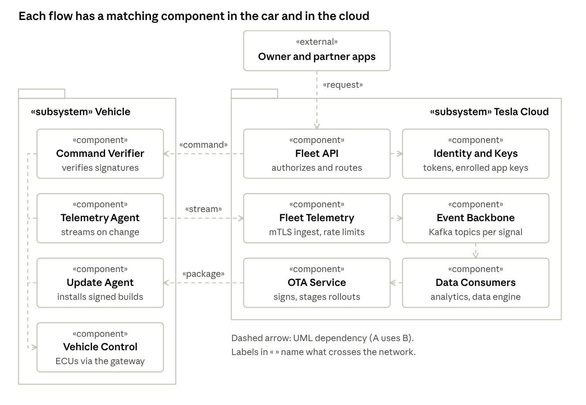
Logical view · UML package and component diagram
Each of the three flows has one component in the car and one in the cloud: the Telemetry Agent feeds Fleet Telemetry, Fleet API reaches the Command Verifier, and the OTA Service reaches the Update Agent. All three car components act on the vehicle only through Vehicle Control, behind the gateway.

4.3 Component-and-Connector View
The component-and-connector view shows how components interact at runtime: the ports they expose and the type of connector between them.
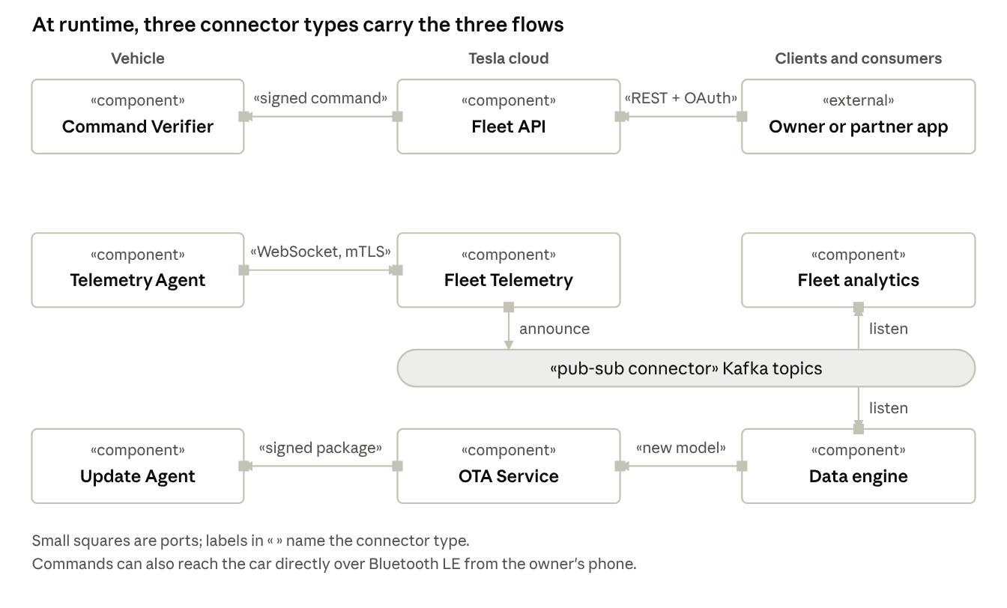
Component-and-connector view · runtime components, ports and connectors
The key connector is the publish-subscribe connector (Kafka): Fleet Telemetry announces events once, and any number of consumers listen without the car or the ingestion server knowing about them. Commands and software use point-to-point connectors, each protected by a signature the car checks.

4.4 Cross-Cutting Technical Decisions
Concern | Decision
Data ownership | The owner approves each app and chooses which signals are shared; consumers build their own views from Kafka topics
Communication | WebSocket with mutual TLS and protobuf for telemetry; REST plus signed command protocol for commands (also over Bluetooth LE); Kafka for internal events
Resilience | On-change sending limits load at the source; rate-limit replies; staged OTA waves limit the impact of a bad build; the car works offline
Identity & security | OAuth tokens checked by the server, owner-enrolled keys checked by the car, mTLS for telemetry, code signing for firmware

5. Migration Strategy & Technical Governance

5.1 Rollout & Migration Pattern
- Patterns selected:
  - Parallel run, then deprecation for moving third parties from the Owner API to the Fleet API and vehicle command protocol.
  - Canary / staged rollout for every OTA software release: a build reaches a small share of cars first and widens only if telemetry and owner reports look clean.
- Execution phases (third-party access migration):
  - Phase 1, late 2023: Fleet API and the vehicle command protocol launch with a free "Discovery" tier; newly delivered vehicles support only the new command path.
  - Phase 2, late 2023 to early 2024: the old Owner API stops accepting commands on existing vehicles; developers move to the HTTP proxy or the SDK. (Timeline as reported by developers; Tesla's exact dates may differ by vehicle.)
  - Phase 3, January 2025: pay-per-use pricing starts, making polling and wake-ups expensive and pushing third parties to Fleet Telemetry streaming.

5.2 Architectural Fitness Functions & Guardrails
What a fitness function is. A normal test checks a feature ("the unlock button works"). A fitness function is an automated check of an architectural property, run on every build or release so the architecture cannot quietly erode. For example: "the car must reject any command that is not signed by an enrolled key." The term comes from Building Evolutionary Architectures (Ford, Parsons and Kua). In Software Architecture in Practice terms, each one turns a quality attribute scenario into a repeatable test.
Tesla does not publish its internal checks. The table below maps each key property to a check that would enforce it, and to what is publicly visible.
Property (from Section 2) | Fitness function (automated check) | Visible at Tesla
Security: only signed commands run | Send unsigned and wrongly signed commands; build fails unless all are rejected | Enforced by the public command protocol
Scalability: ingestion survives bursts | Simulate mass reconnects; check no accepted event is lost and excess gets rate-limited | Rate-limit replies exist in Fleet Telemetry
Deployability: a bad build cannot reach the whole fleet | Each OTA wave widens only if telemetry from the previous wave is healthy | Staged rollout waves are observed by owners
Modifiability: consumers don't break on change | Contract test on the protobuf telemetry schemas for backward compatibility | Schemas are published in the open-source repo
Safety: driving never depends on the cloud | Dependency rule: safety modules may not call network services | Not public (inferred)

6. Architectural Evaluation & Long-Term Retrospective

6.1 Results vs. Quality Attribute Scenarios
Key results
- 2.03 million cars fixed with zero service visits (2023 OTA recall), compared with 134,951 cars that needed a workshop visit when the fault was hardware (2021).
- Trillions of events per day processed by a small platform team.
- No command runs without the car's own signature check since the signed command protocol replaced the old API.
Scenario | Target (Section 2) | Result | Verdict
Deployability | Fleet-wide fix without service visits | 2.03 million US cars fixed by OTA (2023); a 2016 security hole fixed in about 10 days | Met
Scalability | Fleet-scale data with no lost events | Trillions of events per day with a handful of engineers; no public data on event loss | Met (loss not reported)
Security | No unauthorised control of a car | Researchers reached the CAN bus in 2016–2018 and an exposed cloud console was abused in 2018; all fixed, and signed commands added since | Partly met: strong now, not always
Energy efficiency | Fresh data without waking cars | Streaming costs far less than polling for third parties ($1 buys about 150,000 signals vs 50 wake-ups) | Met
Modifiability | New consumer without changing cars | Follows from the publish-subscribe design | Met by design (inferred)
Availability | Car works when offline | No public incident data | Not measurable from public sources

6.2 Total Cost of Ownership (TCO) & Operational Load
- Infrastructure cost impact: Tesla's internal costs are not published. For the ecosystem, pay-per-use pricing (from January 2025) makes streaming far cheaper than polling: $1 buys about 150,000 streamed signals, 1,000 commands, 500 data requests or 50 wake-ups. One third-party service estimated its bill would exceed $1 million a year if it kept polling, which forced a switch to streaming.
- Team cognitive load & velocity: internally, a Kafka-centred platform lets a small team operate at fleet scale. Externally, load moved to third parties, who now run their own telemetry servers, certificates and key enrollment.

6.3 Accepted Technical Debt & Evolution Triggers
- Accepted concessions:
  - Pre-2021 Model S and X remain on an older command path
  - Legacy CAN-bus ECUs need gateway isolation rather than end-to-end security
  - Third-party developers depend on pricing and API rules Tesla controls
- Triggers for re-architecture (inferred, for discussion):
  - If per-vehicle data volume grows sharply (for example, more camera-derived signals), push more aggregation to the edge before upload
  - If vehicle cybersecurity and software-update regulation tightens, formalise update audit trails and rollback evidence
  - If third-party adoption stalls because of cost or complexity, offer managed streaming sinks instead of self-hosted servers

Sources
- teslamotors/fleet-telemetry (GitHub)
- teslamotors/vehicle-command (GitHub)
- Stream processing IoT data: best practices (Confluent, by Tesla's stream-processing lead)
- Tesla Q2 2026 production and deliveries (SEC 8-K)
- Tesla set to deliver 10 millionth vehicle (Basenor)
- Tesla Autopilot recall via OTA (The EV Report)
- Tesla Fleet API pricing (Not a Tesla App)
- Tesla Fleet API pay-per-use pricing (Teslemetry)
- Owner API deprecation timeline discussion (Tesla Motors Club forum)
- Free-Fall: Hacking Tesla from Wireless to CAN Bus (Keen Lab, Black Hat 2017)
- Over-the-Air: How we remotely compromised the Gateway, BCM and Autopilot ECUs (Keen Lab, Black Hat 2018)
- Tesla internal servers infected with cryptocurrency miner (BleepingComputer)
- In-depth explanation of Tesla's OTA system (42how)
- Bass, Clements and Kazman, Software Architecture in Practice (quality attribute scenarios, tactics, patterns)
Added for the recall comparison and fitness functions:
- Fiat Chrysler recalls 1.4 million vehicles over hacking, fix sent on USB drives (TechCrunch, 2015)
- Tesla recalls 135,000 Model S and X to replace touchscreen memory (CNBC, 2021) and NHTSA investigation EA20-003
- Ford, Parsons and Kua, Building Evolutionary Architectures (fitness functions)

